
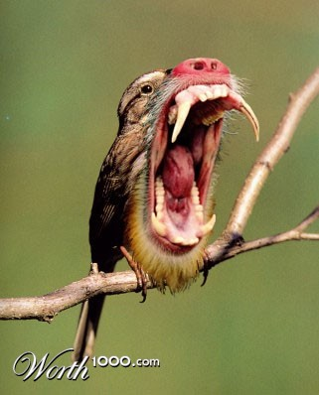
Project: Animal Hybrids

MEETS FLORIDA STANDARDS: 01.0, 02.0, 03.0, 04.0, 08.0, 09.0, 10.0, 19.0, 21.0, 23.0

TASK:
Choose a couple of animals and using your newfound masking skills, mask them together using Photoshop tools. You’ll be creating three unique new species. What will you name them?
Have a look at some examples

WORK FLOW & TIPS:
- Use Masking
- Image search animals. The less alike the better.
- Look for high resolution (DPI) images and animals that are facing standing sitting in like positions.
- Remember, when masking, Black Reveals, White Conceals
- Try and match colors using Image - Adjust - Hue and Saturation.
- Use Levels and Curves to adjust blacks whites and greys
- Adjust your brush to have 75% or lower opacity.

OUTCOME:
- Students use their design skills to use middle level sophistication tool and begin the first steps towards photo restoration.
- Students become more familiar with the Adobe Photoshop toolsets and interface

PRE-PRODUCTION
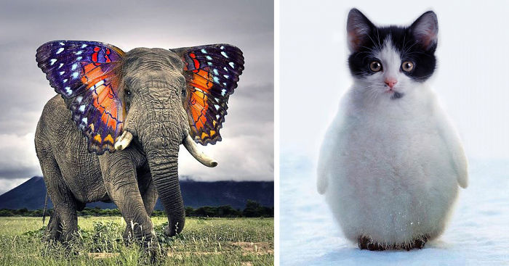
Brainstorm and gather information related to your inspiration.
- Gather high resolution photos. High dpi. Use LARGE image search
- Look at examples here.

PRODUCTION & POST PRODUCTION

Create your artwork.
- Using Adobe Photoshop, use all the tools at your disposal to create several hybrid animals.
- Make sure to list the species name in an appropriate font underneath your photo.
Kittenguin (Cat and penguin) Butterphant (Butterfly Elephant).

Prepare it for output and Turning It in
- Grab a COPY MERGED version of your PSD / Layers / Mask file. Save it in a PNG file format and turn it in. Put your name in the description line.

Grading Rubric – 3 points

An A grade will look like: 3 points
Your attention to detail is self evident. You followed the outline exactly as explained. You incorporated original thoughts and ideas. The artwork is personal, of your choice and of professional standards you set.

A B grade will look like: 2.5 points
Your attention to detail is evident in parts of your final. You followed the outline mostly as explained. You incorporated some original thoughts and ideas. Your idea and artwork is of professional standards, but has some room for revisions. Your letter may contain a few typos.

A C grade will look like: 2 points
Your attention to detail is evident in some of your final. You followed the outline mostly as explained, but are missing one or more key elements asked for. You incorporated a few original thoughts and ideas. The artwork is of minimal professional standards, has some room for improvements and revisions and should be corrected before mailing. Your letter has spelling and punctuation errors that should also be looked at before mailing.

A D grade will look like: 1 points
Your attention to detail is evident in almost no part your final. You did not follow the outline as explained, and are missing more than one key elements asked for. There is no thought given to originality. It’s minimal or even too much. The artwork is not of professional standards yet and should be corrected if giving this to a client. Your letter has spelling and usage issues. Maybe does not make much sense.

A Failing grade will mean: 0 points
The project is either not turned in, incomplete and there was no attention paid to the instructions provided. There is no thought given to originality. The artwork is not of professional standards. The idea most likely should have been abandoned in favor of another approach.

